LAB 2 HASHING
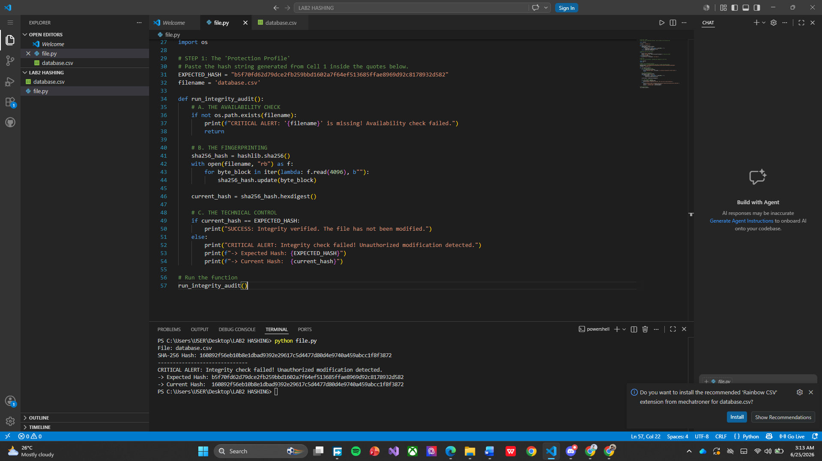s
The integrity check failed because the SHA-256 hash calculated from the current database.csv file does not match the expected hash stored in the program. A SHA-256 hash acts like a unique digital fingerprint for a file, so even a small change—such as adding, deleting, or modifying a single character—will produce a completely different hash value. Since the expected hash (b5f70fd62d79dce2fb259bdd1602a7f64ef513685ffae8969d92c8178932d582) differs from the current hash (160892f56eb10b8e1dbad9392e29617c5d4477d80d4e9740a459abcc1f8f3872), the program correctly reports an integrity check failure and flags the file as having been modified.

